**Hope Artificial Intelligence**

**Assignment-Classification Algorithms**

**Logistic Regression:**

**Passed Parameter**

Penalty = l2

Solver = newton-cg

Random_state =0

**Confusion Matrix**

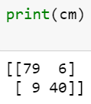

**Classification Report**

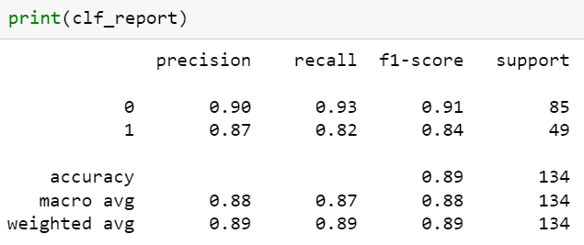

**Question and Answer for Random Tree from above result**

**Question 1:**

1. What proportions of the model’s predictions are correct?

(or)

1. What is the overall correctness percentage for both 'purchased' and 'not-purchased' categories with respect to the entire test set?

**Answer:**

|  |  |
| --- | --- |
| **Formula** | **Value** |
|  | 0.89 |

**Question 2:**

1. What is the accuracy percentage for correctly classifying 'purchased/not-purchased' items in the total test set?

(Or)

1. Could you provide the percentage of accurate classifications for 'purchased/not-purchased' items in relation to the entire test set?

**Answer:**

|  |  |
| --- | --- |
| **Formula** | **Value** |
|  | |  |  | | --- | --- | | **Purchased = 1** | **0.82** | | **Not Purchased = 0** | **0.93** | |

**Question 3:**

1. What portion of instances classified as 'purchased/not-purchased' corresponds to the precision percentage, considering both true positives and false positives in the test set?

(Or)

1. How often are 'purchased/not-purchased' items correctly identified, expressed as a percentage of the sum of correct and incorrect classifications for 'purchased' in the test set?

**Answer**

|  |  |
| --- | --- |
| **Formula** | **Value** |
|  | |  |  | | --- | --- | | **Purchased = 1** | **0.87** | | **Not Purchased = 0** | **0.90** | |

**Question 4:**

1. What is the combined performance for 'purchased' and 'non-purchased' categories?

(Or)

1. Could you elaborate on the combined performance metrics for both 'purchased' and 'non-purchased' outcomes?

**Answer**

|  |  |
| --- | --- |
| **Formula** | **Value** |
|  | |  |  | | --- | --- | | **Purchased = 1** | **0.84** | | **Not Purchased = 0** | **0.91** | |

**Question 5.1**

1. Could you elaborate on the overall precision performance, taking into account both correct and incorrect classifications?

(Or)

1. What is the combined precision score, considering both accurate and inaccurate classifications?

**Answer**

|  |  |
| --- | --- |
| **Formula** | **Value** |
|  | 0.88 |

**Question 5.2**

1. Can you provide insights into the overall recall performance, considering instances that were correctly identified?

(Or)

1. What is the combined recall score, focusing on instances that were correctly classified?

**Answer**

|  |  |
| --- | --- |
| **Formula** | **Value** |
|  | **0.87** |

**Question 5.3**

1. Can you provide insights into the overall performance captured by the F1 Measure?

(Or)

1. What is the combined F1 Measure score, representing the average performance across precision and recall?

**Answer**

|  |  |
| --- | --- |
| **Formula** | **Value** |
|  | 0.88 |

**Question 6**

1. Could you provide the total obtained by multiplying the proportion rates (weights) for each class and summing them?

(Or)

1. What is the cumulative result of multiplying and summing the proportion rates (weights) assigned to each class?

**Answer**

|  |  |
| --- | --- |
| **Formula** | **Value** |
| Precision(Apple)*(85/134)+Precision(Orange)*(49/134) | 0.89 |
| Recall(Apple)*(85/134)+Recall(Orange)*(49/134) | 0.89 |
| F1(Apple)*(85/134)+F2(Orange)*(49/134) | 0.89 |

**Question 7:**

What is the support value for Purchased and Not Purchased from test data?

**Answer**

Total count of Purchased = 85

Total count of Not Purchased = 49

**Question 8:**

**What is the sum of all value for Purchased and Not Purchased from test data?**

**Answer**

Total Count of Purchased and Not Purchased = 134